**Wireshark Lab 2**

1. The IP address for the server *www.channelnewsasia.com* is 104.68.227.65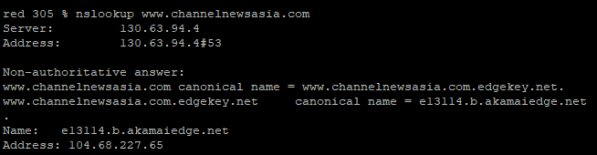
2. The authoritative DNS servers are the four servers that appear below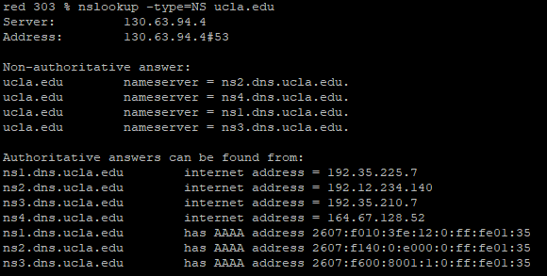
3. The IP address of the server is 192.35.225.7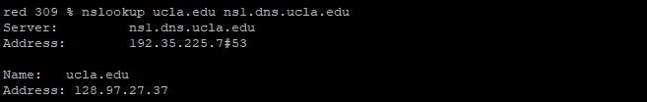
4. The DNS query and response messages are sent over UDP.
5. The destination port is 53 and the source port is 49567.
6. The DNS query was sent to IP address 192.168.1.1 and the IP address of my local DNS server is 192.168.1.1. Therefore these two addresses are the same.

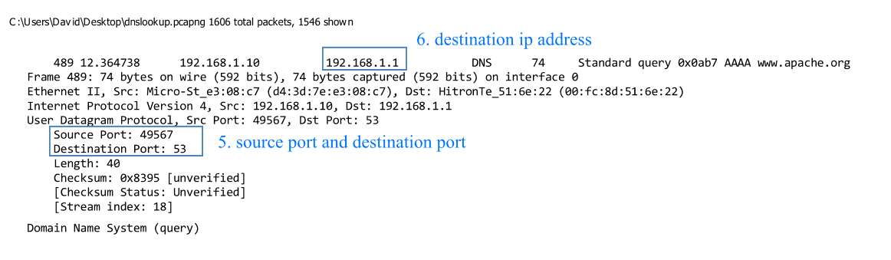

1. The query message was Type AAAA. The query did not contain any answers. 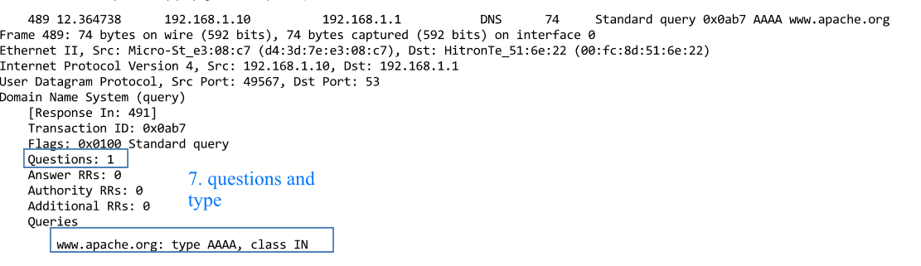
2. The response message contained one answer to the query address. It also provided the authoritative nameservers.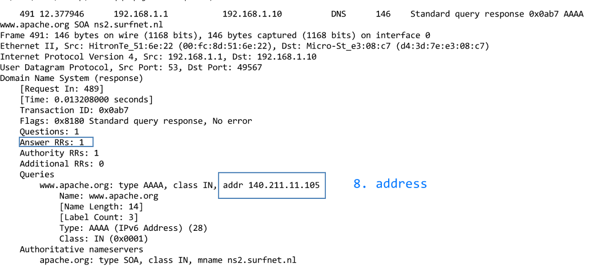
3. The destination of the SYN packet is 140.211.11.105
4. No it did not issue new DNS queries for the images.

**Theory Question**

The TCP congestion window will start off at 1 and will send an initial segment. It will then wait until the ACK arrives and will then increase the congestion window to 2. Then 2 segments will be sent. The TCP will then wait again until it repeats this step for each segment. This results in logN amount of segments with each segment doing logN work. Therefore to send N segments it will take log2N trips.